**DCCM物流管理SO业务操作测试说明V1.0**

**2017-12-07**

## SO销售出货

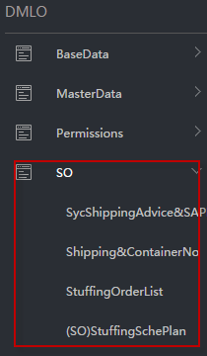

### 数据同步Syc ShippingAdvice&SAPDO

关联ShippingAdvice、SAP Delivery Order

#### 2.1 Create a New Form

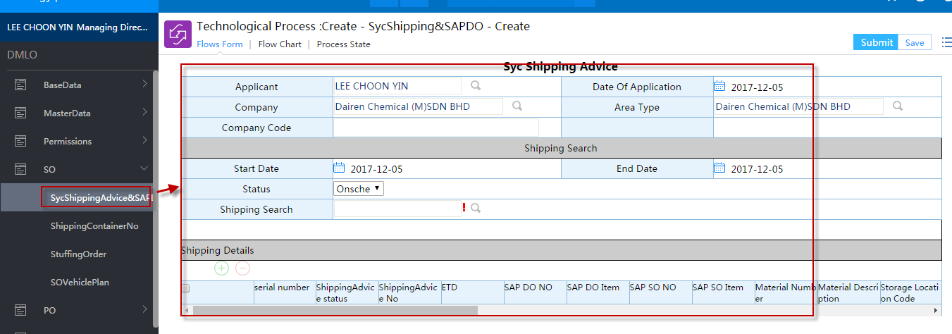

#### 2.2 Select ShippingAdvice

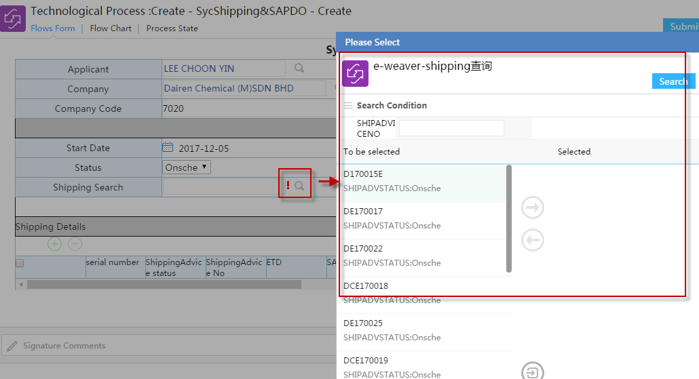

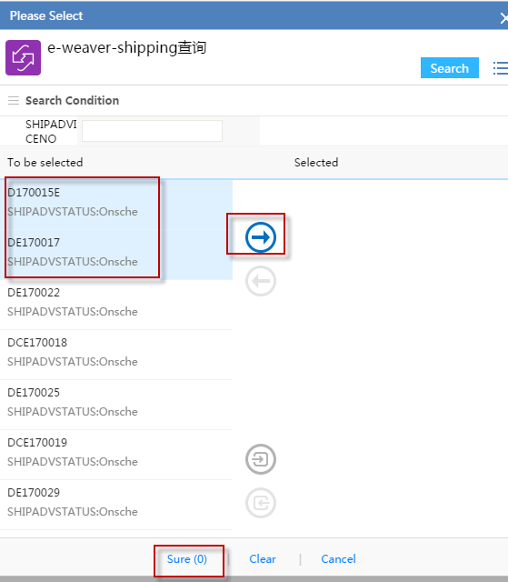

Submit

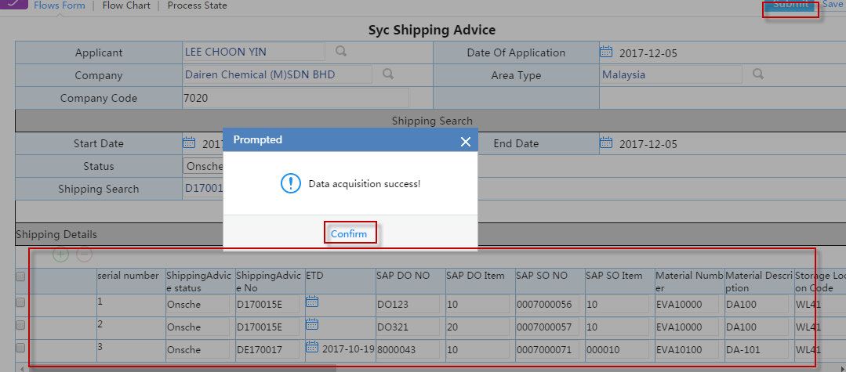

### 柜号录入Shipping&ContainerNo

Shipping柜号或ISOTANK号对应，文件组录入

#### Menu

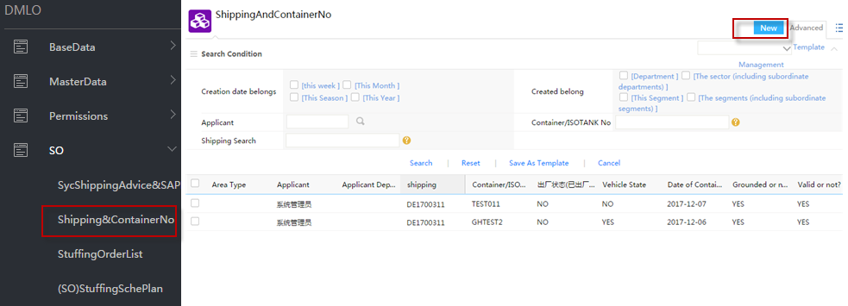

#### New

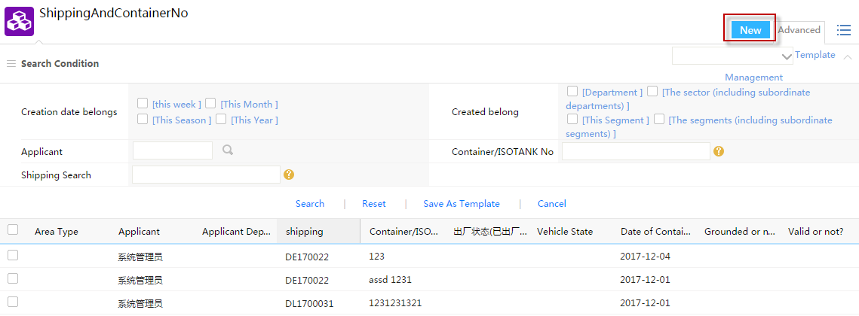

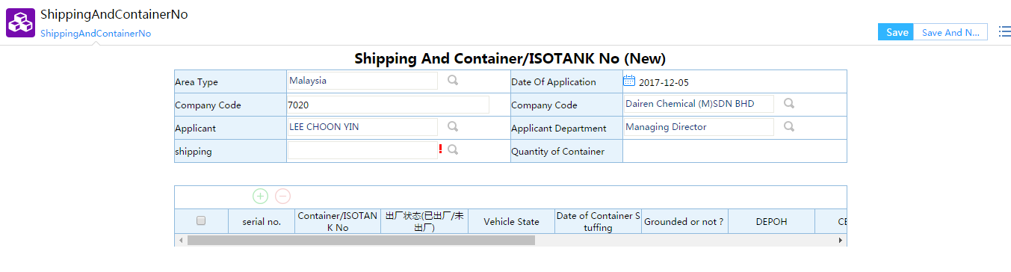

#### Select Shipping Advice No

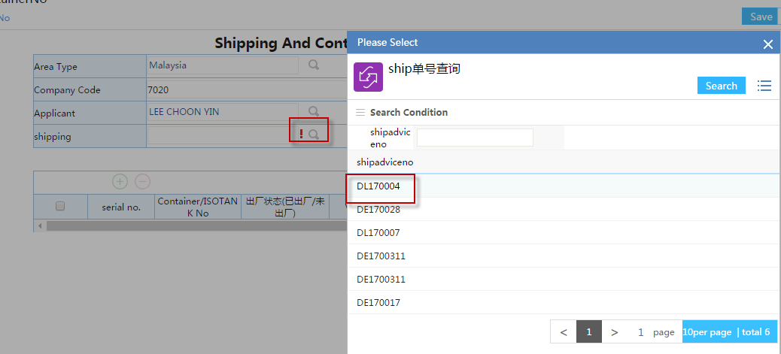

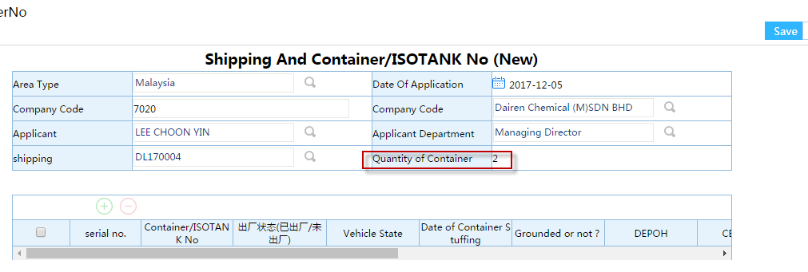

#### Input Details of Container or ISOTANK

Container/ISOTANK No、Date of Container Stuffing、Grounded or not?、Depot Supplier、CBM(M3)、

Remark etc.

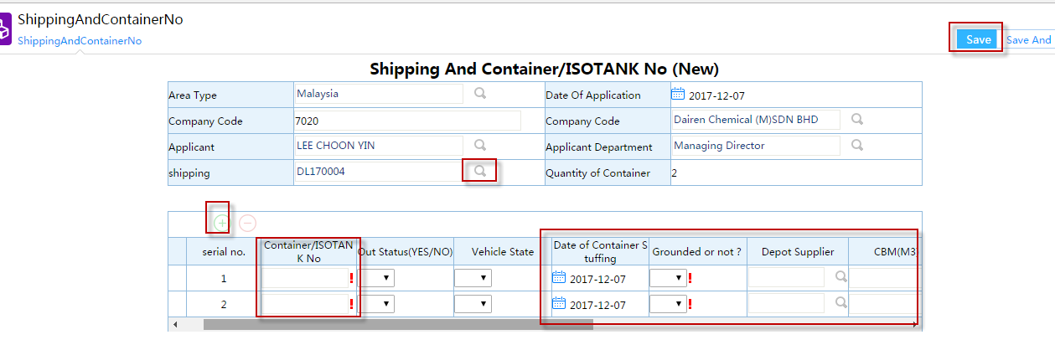

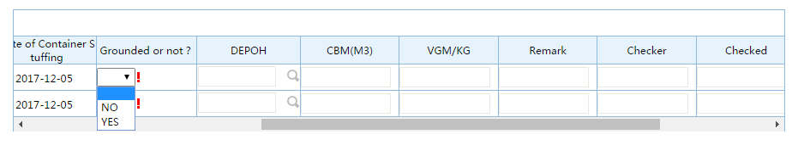

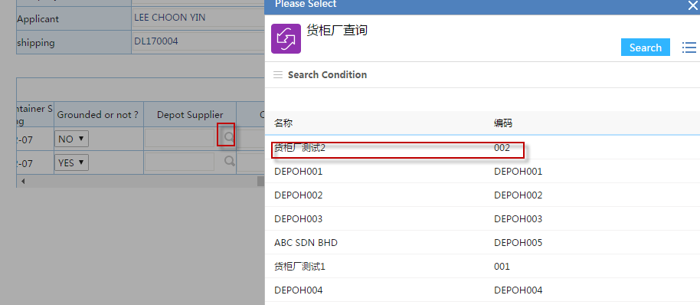

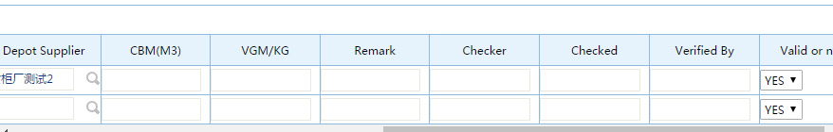

#### Save

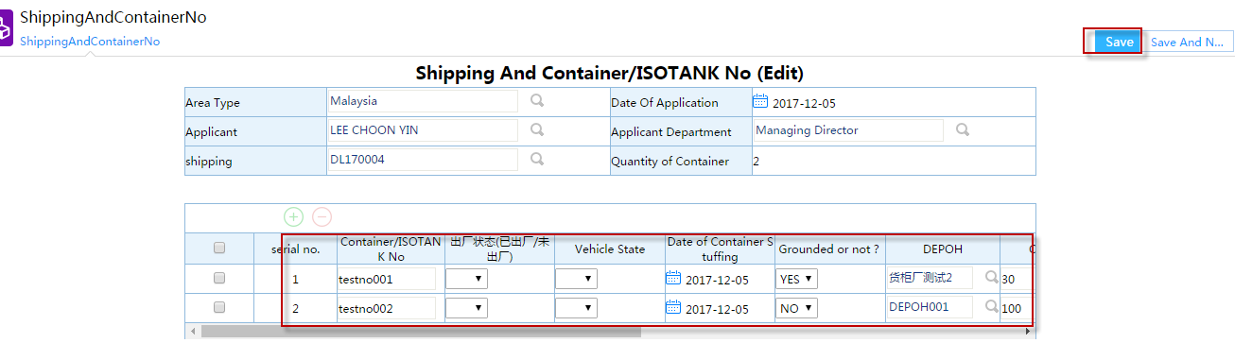

#### Edit

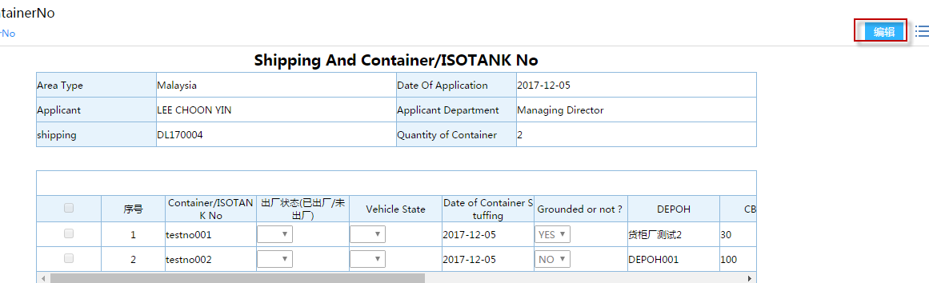

### 理货清单StuffingOrderList

#### Menu

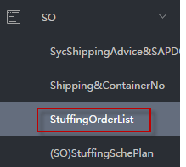

#### Create a New Stuffing Order List

select “Yes or No With Container”

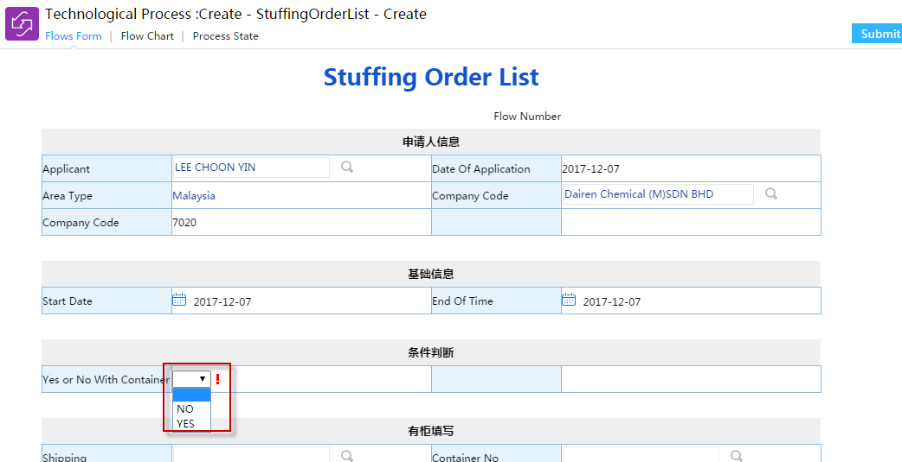

#### With Container/ISO TANK

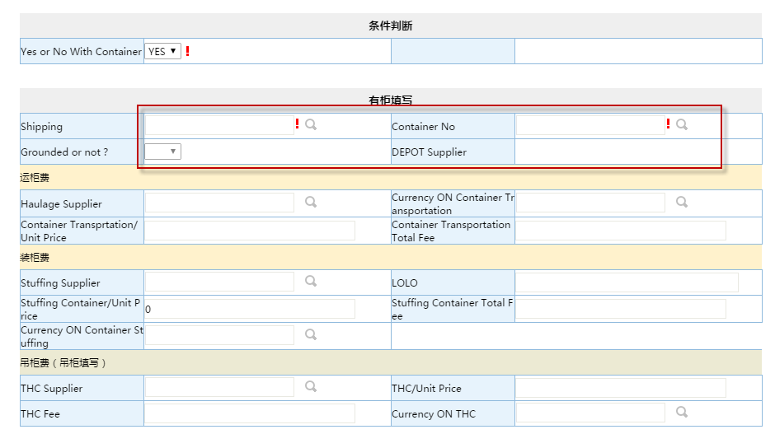

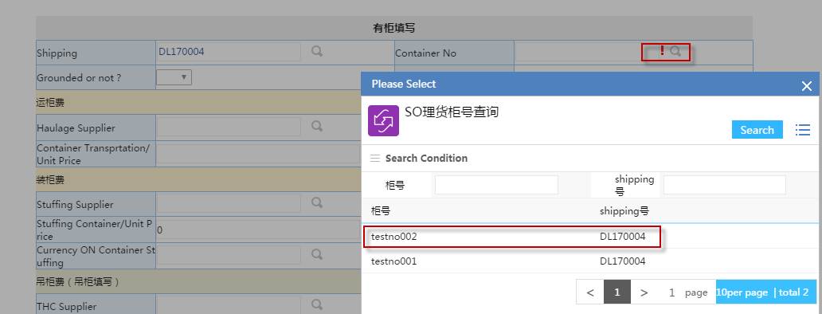

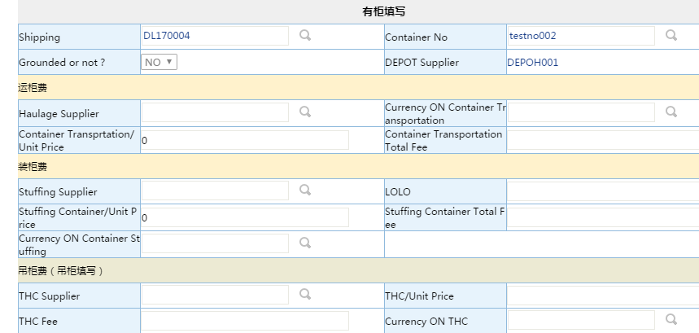

For example: MasterData\LOPrice\Container Price

|  |  |  |  |  |  |  |  |
| --- | --- | --- | --- | --- | --- | --- | --- |
| **Fee Name** | **Supplier Name** | **Supplier Code** | **Depot Supplier** | **LOLO** | **Unit Price** | **Currency** | **Status(Active/InActive)** |
| Container Transportation Fee | COGNIS OLEOCHEMICALS(M) SDN BHD | COG001 | ABC SDN BHD |  | 150.00 | MYR | Active |
| Stuffing Container Fee | B & T HOLIDAY TOURS SDN BHD | DCM043 | ABC SDN BHD | LOLO1 | 120.00 | MYR | Active |
| THC Fee | TATA Grounded SDN BHD | DCM044 |  |  | 50.00 | MYR | Active |

#### 未完待续……

### 4.SO装卸计划Loading/UnloadingPlan